**Mist Makers**

The small Mist Maker makes an attractive indoor water feature. The mist contains negative ions which help to freshen the air. The vaporized water adds to the humidity of the room.

**MM1**

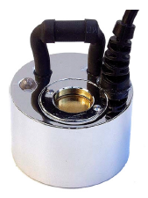Cable length: 1.8m

Power:AC24V 36 Watt

Depth below surface: 25-45MM

Mist volume: 550 ml/h

Dimensions: Ø 40mm H 45mm

Housing material: Stainless Steel

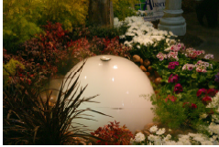**MM5**

Cable length: 10m

Power:AC24V 124 Watt

Depth below surface: 30-50MM

Mist volume: 1600 ml/h

Dimensions: Ø 85mm H 55mm

Housing material: Stainless Steel

**MM6**

Cable length: 10m

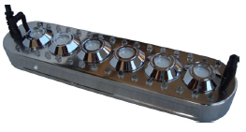Power:AC24V 240 Watt

Depth below surface: 30-50MM

Mist volume: 2800 ml/h

Dimensions: Ø 60mm H 60mm

Housing material: Stainless Steel

**MM9**

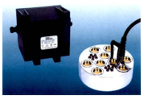Cable length: 10m

Power:AC36V 280 Watt

Depth below surface: 30-50MM

Mist volume: 5000 ml/h

Dimensions: Ø 120mm H 55mm

Housing material: Stainless Steel

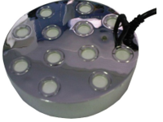**MM12**

Cable length: 10m

Power:AC36V 300 Watt

Depth below surface: 60-80MM

Mist volume: 5300 ml/h

Dimensions: Ø 150mm H 55mm

Housing material: Stainless Steel

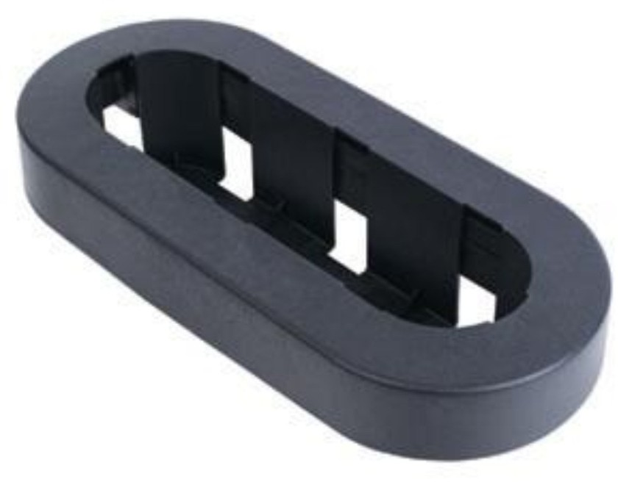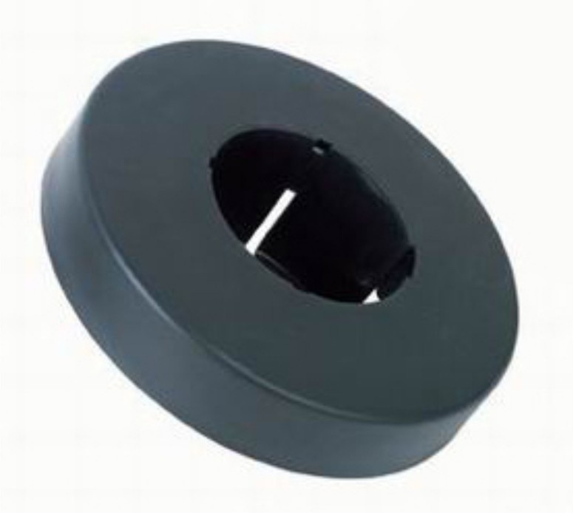

**Float Rings**

Ideal for ponds and water features that

are too deep. Ensures that units are

kept at the right level, ensuring optimal

mist generation